CS570
Analysis of Algorithms
Summer 2010
Final Exam

Name: _____________________
Student ID: _________________
____Check if DEN student

 | Maximum | Received
Problem 1 | 20
Problem 2 | 20
Problem 3 | 20
Problem 4 | 15
Problem 5 | 15
Problem 6 | 10
Total | 100

2 hr exam
Close book and notes

- 20 pts
Mark the following statements as TRUE, FALSE, or UNKOWN. No need to provide any justification.
[ TRUE/FALSE ]
Given a network G(V, E) and flow f, and the residual graph G_{f} (V’, E’), then |V|=|V’| and 2|E|>=|E’|.

[ TRUE/FALSE ]
The Ford-Fulkerson Algorithm terminates when the source s is not reachable from the
sink t in the residual graph.

[ TRUE/FALSE/UNKOWN ]
NP is the class of problems that are not solvable in polynomial time.
[ TRUE/FALSE/UNKOWN ]
If problem A is NP complete, and problem B can be reduced to problem A in quadratic time. Then problem B is also NP complete

[ TRUE/FALSE/UNKOWN ]
If X can be reduced in polynomial time to Y and Z can be reduced in polynomial time to Y, then X can be reduced in polynomial time to Z.

[ TRUE/FALSE ]
Let G(V,E) be a weighted graph and let T be a minimum spanning tree of G obtained using Prim’s algorithm. The path in T between s (the root of the MST) and any other node in the tree must be a shortest path in G.

[ TRUE/FALSE ]
DFS can be used to find the shortest path between any two nodes in a non-weighted
graph.
[ TRUE/FALSE ]
The Bellman-Ford algorithm cannot be parallelized if there are negative cost edges in
the network.

[ TRUE/FALSE ]
A perfect matching in a bipartite graph can be found using a maximum-ﬂow
algorithm.
[ TRUE/FALSE ]
Max flow in a flow network with integer capacities can be found exactly using linear programming.

2.We know that max-flow problems can be solved in polynomial time. However, consider a modified max-flow problem in which every edge must either have zero flow or be completely saturated. In other words, if there is any flow through an edge at all, the flow through the edge is the capacity of the edge. Let’s call a flow a saturated flow if it satisfies this additional constraint, as well as the usual constraints of flow problems. The modified problem asks us to find the maximum saturated flow.

a.(2 point) Formulate this problem as a decision (yes/no) problem. (We’ll call it MAX-SATURATED-FLOW.) Write your answer in the form of a question.
ANSWER.
Is there a saturated ﬂow of value k or greater? (Alternative: is there a saturated ﬂow of value k?) Here, k is an arbitrary number.

b. (5 points) Show that MAX-SATURATED-FLOW is in NP.
ANSWER.
For a certiﬁcate, we use a list of all the saturated edges. Given such a list, we can check in linear time the ﬂow out of the source node, and whether the conservation condition for each node (exceptthe source and sink) is satisﬁed.

c. (13 points) Show that MAX-SATURATED-FLOW is NP-hard. Hint: use subset-sum problem.
ANSWER.
It’s relatively easy to reduce SUBSET-SUM to MAX-SATURATED-FLOW. Consider the NP-hard problem of ﬁnding a subset of { s₁, s₂ …s_{n}}that sums to t. This problem is solved if we ﬁnd a saturated ﬂow of value t in the following graph (or alternatively, the amaximum saturated ﬂow of this graph).

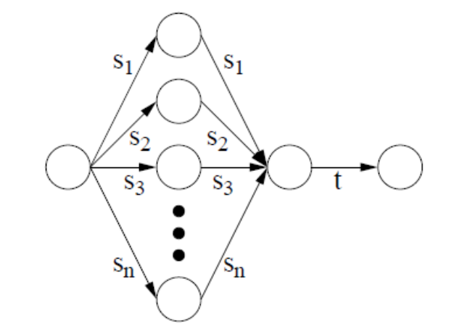

3.Consider a 2-D map with a horizontal river passing through its center. There are n cities on the southern bank with x-coordinates a(1) ... a(n) and n cities on the northern bank with x-coordinates b(1) ... b(n). Note that the x-coordinates are NOT in sorted order. You want to connect as many north-south pairs of cities as possible with bridges such that no two bridges cross. But when connecting cities, you can only connect city i on the northern bank to the corresponding city i on the southern bank. Design an efficient algorithm for that.

Answer:
Let’s us first interpret the question correctly. We want to build as many none crossing bridge as possible. As shown in the following image,
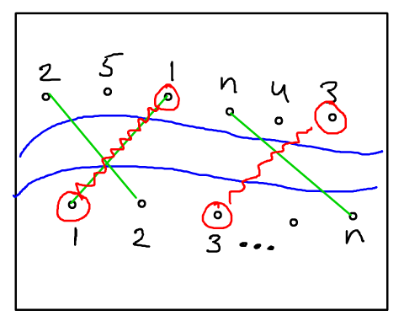
In the lower level of river, we use 1…n to denote all the cities in the south, in the upper level of the river, we use the same number to denote the corresponding city in the north.
Our problem is to connect as many of them as possible.

Let X(i) to be the index of corresponding city on the northern bank (e.g., X(1) = 3 in the above figure). To compute each X(i), we need O(n) time
Therefore, the problem to reduce to “Find the longest increasing subsequence in X(1)…X(n)”. This problem is solved in Homework 4, please refer to the solution of problem 3 in Homework 4.

The complexity of overall algorithm is O(n²)

Grading Strategy:
Correct Solution: 12 points
Complexity : 4 points.
Correctness Proof: 4 points

Any CORRECT solution within time complexity O(n³) (including O(n³)) will receive full credits for the solution part, otherwise, will minus one or two points.

4.15 pts
Consider the following vertex cover algorithm for an undirected graph G = (V, E).
0. Initialize C = Null set.
1. Pick any edge e = (u, v) ϵ E, add u and v to C. Delete all edges incident on
either u or v.
2. If E is empty, Output C and exit. Otherwise, go to step 1.
Show that C is a vertex cover and that the size of C is at most twice as big as the minimum vertex cover. (Thus we have a 2-approximation)

Answer:
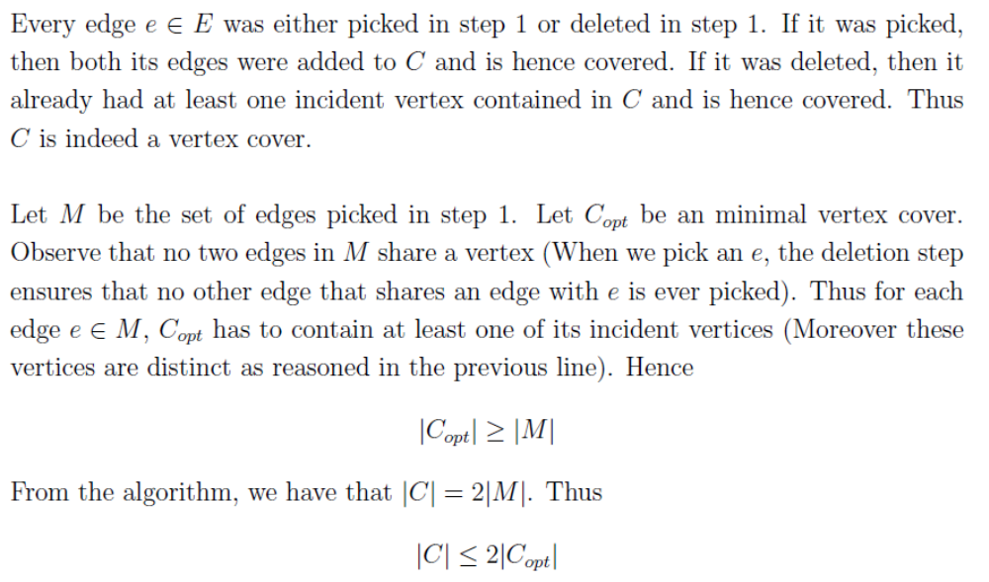

5.15 pts
- Show that an undirected graph has a unique minimum spanning tree if, for every cut of the graph, there is a unique light edge (i.e., a unique edge of smallest cost) crossing the cut.
- Show that the converse is not true by giving a counterexample.

Answer:
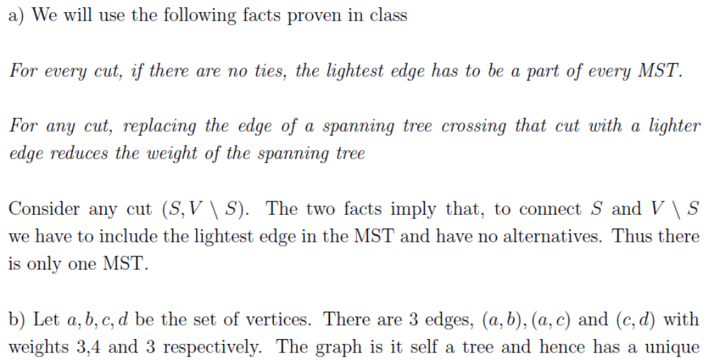

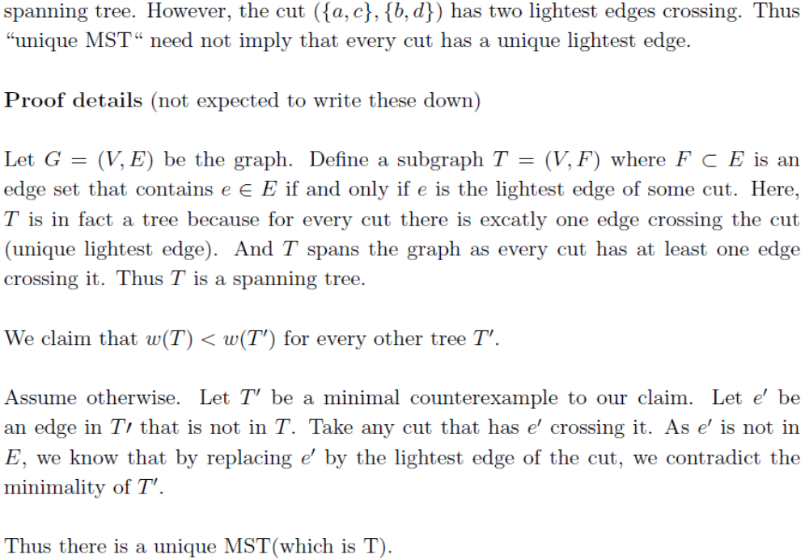

- 10 pts
Consider a long country road with houses scattered very sparsely along it. You want to place cell phone base stations at certain points along the road, so that every house is within four miles of one of the base stations. Give an efficient algorithm that achieves this goal, using as few base stations as possible.

Answer:

The algorithm to locate the least number of base stations is given as follows:
Line 1 Start from the beginning of the road
Line 2 Find the first uncovered house on the road
Line 3 If there is no such a house, terminate this algorithm; otherwise, go to next line
Line 4 Locate a base station at 4 miles away after you find this house along the road
Line 5 Go to Line 2

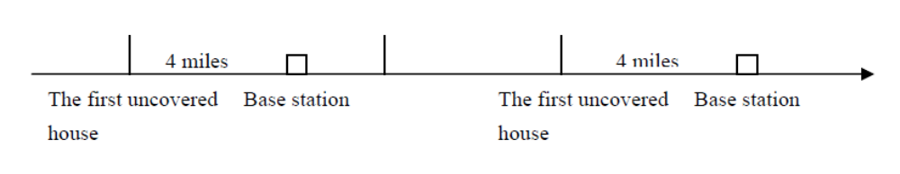

This algorithm is O(n).
Now we prove its correctness. We want to show that this algorithm (denoted by S) does provide the smallest number of base stations. Let some other optimal solution be S’. Let DS(i) denote the number of homes covered by first i base stations in solution S. We now show DS(i)>DS’(i) for all i.
First, we can see DS(1)>=DS’(1) because S tries to put the first base station as faraway to the first home as possible.
Now given DS(i)>=DS’(i), we show that DS(i+1)>=DS’(i+1). This is true unless in S’ the (i+1)th base station cover at least one more home than the (i+1)th base station in S further down the road. This is not possible because according to our greedy approach we have covered as far as possible in S. Thus this base station in S’ much covered more than 8 miles. This is contradiction.
Therefore we proved the correctness of our algorithm.

